Case study on Digital Transformation adopted in the UK Bank

***By***

***V.Radhakrishnan***

Contents

1. Introduction 3

*2.* *Background of the Organisation* 5

3. Case Facts 6

4. Analysis of facts 6

5. Assessment of Digital Transformation 7

***5.1*** ***Digital Automation of a Manual Work using BOT*** 7

***Build:*** 7

***Operate:*** 7

***Transfer:*** 8

In this phase, project ownership is finally transferred to the client, but only when the client is fully ready to control the project or when the contract expires. It includes new offshore subsidiary for the customer, transfer assets, and handover operation. 8

6. Summary/Conclusions with Recommendations 11

6.1 Benefits of Build-Operate-Transfer Model 11

• ***Save money and make the company more profitable.*** 11

• ***Help product come to the market faster.*** 11

• ***Minimize the risks*** 11

# Introduction

**Digital transformation is the profound transformation of business and organizational activities, processes, competencies and models to fully leverage the changes and opportunities of a mix of digital technologies and their accelerating impact across society in a strategic and prioritized way, with present and future shifts in mind.**

While digital transformation is predominantly used in a business context, it also impacts other organizations such as governments, public sector agencies and organizations which are involved in tackling societal challenges such as pollution and aging populations by leveraging one or more of these existing and emerging technologies.

Present and future shifts and changes, leading to the necessity of a faster deployment of a digital transformation strategy, can be induced by several causes, often at the same time, on the levels of customer behaviour and expectations, new economic realities, societal shifts (e.g. aging populations), ecosystem/industry disruption and (the accelerating adoption and innovation regarding) emerging or existing digital technologies. In practice, end-to-end [customer experience](https://www.i-scoop.eu/customer-experience/) optimization, operational flexibility and innovation, are key drivers of digital transformation, along with the development of new revenue sources and information-powered ecosystems of value, leading to business model transformations.

**Digital transformation is a journey with multiple connected intermediary goals, in the end striving towards continuous optimization across processes, divisions and the business ecosystem of a hyper-connected age where building the right bridges in function of that journey is key to succeed.**

A [digital transformation strategy](https://www.i-scoop.eu/digital-transformation/digital-transformation-strategy/) aims to create the capabilities of fully leveraging the possibilities and opportunities of new technologies and their impact faster, better and in more innovative way in the future. A digital transformation journey needs a staged approach with a clear roadmap, involving a variety of stakeholders, beyond silos and internal/external limitations. This roadmap takes into account that end goals will continue to move as digital transformation de facto is an ongoing journey, as is change and digital innovation.

Technology is disrupting established ways of doing business. The opportunities which have opened up for those organisations able and capable of embracing emergent technology are immense.

All new initiatives should now take a ‘Digital First’ approach, with the rapid evolution in mobile, social media, cloud and big data changing the way we all interact. Consumers of all ages are gaining familiarity and comfort with a wide range of digital channels and are increasingly expecting high standards of digitisation.

Digital disruption has brought about significant changes in the way companies do their business. With rapidly advancing analytics capabilities owing to the incorporation of machine learning and artificial intelligence, businesses are able to streamline their operations, create new revenue models, and elevate customer experience management.

Digital transformation is profound change in business activities, processes, competencies, and models to fully leverage customers at every touchpoint in the customer experience.

Successful digital transformation achieve these results:

* CUSTOMER: Harness customer networks and reinvent the path to purchase in line with their real behaviors
* COMPETITION: Rethink the competition and build platforms that deliver competitive advantage
* DATA: Turn data into assets that prove results in real time
* INNOVATION: Innovate by rapid experimentation
* VALUE: Judge change by how digital transformation helps create the next business

Enterprises across the globe face many challenges on a day to day basis.

Immediately, there is the challenge to face up to and meet head on the three business pre-requisites of Retaining Customers, Controlling Costs and Gaining Competitive Advantages.

Today, these three challenges are immense. Competitors target your customers, elements of your costs structures are at the mercy of currency fluctuations and the commoditisation of many markets limits your possibilities for any differentiation other than price.

But, organisations and enterprises are finding solutions and these do not involve deploying more of the same, already failing business tactics. Instead, and for some time now, business leaders have been adopting new collaborative and customer centric strategies, termed Digital Transformations (DX), that places users and user needs at the heart of their business operations.

# *Background of the Organisation*

A British [multinational](https://en.wikipedia.org/wiki/Multinational_corporation) banking and [financial services](https://en.wikipedia.org/wiki/Financial_service) company headquartered in UK. It operates a network of more than 1,200 branches and outlets (including subsidiaries, associates and joint ventures) across more than 70 countries and employs around 87,000 people. It is a [universal bank](https://en.wikipedia.org/wiki/Universal_bank) with operations in consumer, corporate and institutional banking, and treasury services

It offers banking services that help people and companies to succeed, creating wealth and growth across the markets. With more than 87,000 employees in more than 70 markets, bank have over a 150-year history in some of the world’s most dynamic regions. It’s listed on the London and Hong Kong Stock Exchanges as well as the Bombay and National Stock Exchanges in India.

It make the most of deep roots in rapidly developing Asian, African and Middle Eastern local markets to seek out opportunities at every turn. Placing a particular focus on supporting customers who trade, operate or invest across the footprint.

What sets it apart is its diversity– of people, cultures and networks. It use this to give the best possible customer experience, whether an individual looking for easy, fast and convenient banking services, or a multinational corporation with highly complex financing needs.

As the economies in core markets grow, so does the need for sophisticated financial services. It believe it is crucial to help its customers adhere to global standards of conduct and compliance. Wherever it operate, the bank aim to support sustainable economic and social development. The Bank do this through it’s core business of banking, ensuring a strong conduct framework, investing in it’s people and working with local partners to deliver community programmes.

The bank is committed to promoting equality in the workplace and creating an inclusive and flexible culture – one where everyone can realise their full potential and make a positive contribution to organisation. This in turn helps to provide better support to our broad client base.

# Case Facts

This is about the process related to name screening activity on the customer records performed in the bank. This is very critical activity where the new customer name is validated against various conditions before the bank services are offered to the customer.

Its kind of bank backend operations which will go has input to the account opening process followed in the bank. This Name screening activity is helps to identify and create alert to the investigators about the customer name identified and it will be treated has separate case which need to be further investigated by the relevant teams.

# Analysis of facts

When an end customer opens a new account, Bank needs to perform various validation on the information provided. Different types of checks will be performed at various stages by the frontend officers and risks will be evaluated based on the investigation performed as per the Bank’s policy.

Post all the information gathered, frontend user will feed the same into the Data Base. The automated scheduled job the information that is greater than two days will be fetched from the DB and will be loaded into another application DB (Second Application) each record will be created as a new case.

Whereas from the second DB will be linked to the front end of the second application, whereas there will be a set of teams nominated to download each cases and cross check the details, post that each single case will be converted as a text document and places in a common path.

With the help of another set of teams, all the text data will be uploaded in the Third application link, where the final validation of the customer will be cross verified. For each case, a set of front end users validate and update the new comment whether the customer information is a valid one or not in case of any crime or any violation this information will also be mentioned in the comment box. Based on the customers information alerts will be created.

Post the teams update, the detail will be updated back to the second application DB and the customer information details will be verified and all relevant information like KYC update and other information will also be captured.

As per the above details there was more number of manual activity done like file creation verifying the recon count bye pre-load and post load details and log check during the DB insertion, file execution status and monitoring various activity. There are also many chances to perform human error, and took more man time, to perform all this cross check and to do updates.

# Assessment of Digital Transformation

## ***Digital Automation of a Manual Work using BOT***

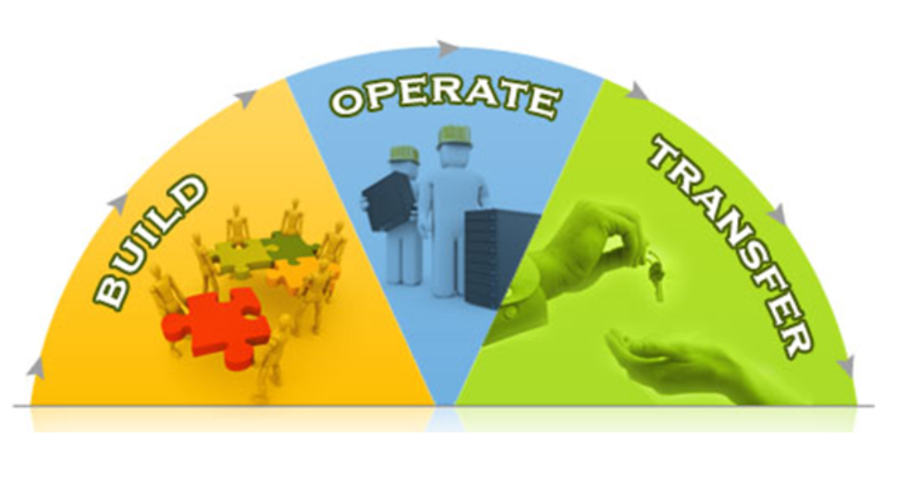

***Introduction******of******BOT****:*

***Build:***

This phase involves setting up of an operation unit which includes everything from selecting buildings, installing infrastructures such as the internet and IT devices, employing staff and putting in place the administration and legal framework.

***Operate:***

This phase manages the offshore project which includes program management, development, maintenance, enhancements and product support.

***Transfer:***

In this phase, project ownership is finally transferred to the client, but only when the client is fully ready to control the project or when the contract expires. It includes new offshore subsidiary for the customer, transfer assets, and handover operation.

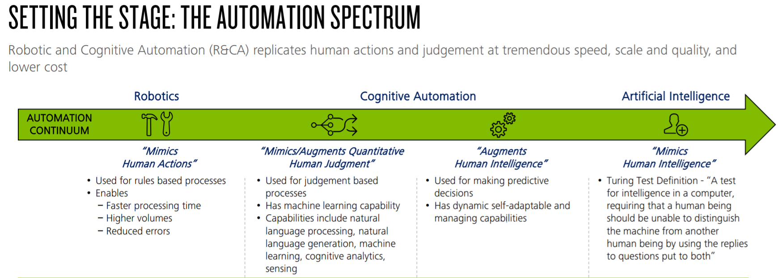

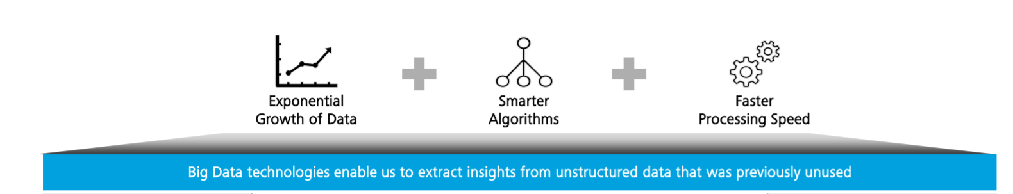

***Introduction of Project which is used for the alert and case creation:***

Bank project is used to cross check and verify the customer related information based on the transaction and personal related information.

Once the Frontend user feed the end customer’s data, the details will be automatically stored in the BOT1 DB. Over all we will be holding all the data, Where the recent two days records that is related to the downstream application will only be fetched from the DB and details will be displayed in the application screen.

BOT is configured in such a way that once the data is been loaded in DB and front end the logs will be verified post the verification BOT will login to the front end link and download the case details and convert the same as a text file.

It will perform the reconciliation process between the files and the data fetched from DB.The BOT will trigger the mail to all the users whom has been mentioned in the list stating that the text file has been created.The crime and compliance team will login to the share path and cross check whether the text files has been created.

Post the CC team confirmation the BOT will automatically login to the downstream system link and will load all the text files that has been created in source system. Downstream team will login to EDD, PEP and Deny and will make sure the all the cases that has been pushed from source system is verified and update the comment in the text box.

In case of any issue alert will be raised and tagged to that particular case.

BOT will now take the case ID (which is Unique) and take the comment details that has been entered by the downstream and update the same in the upstream. Post that the customer verification details will be published to all the frontend users.

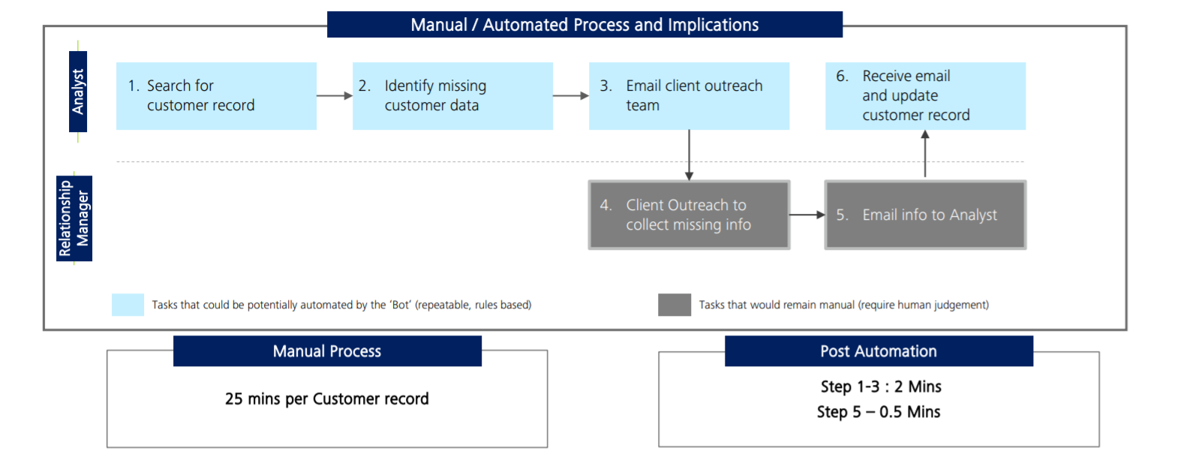

# Summary/Conclusions with Recommendations

## Benefits of Build-Operate-Transfer Model

### ***Save money and make the company more profitable.***

Business is all about saving a dollar rather than selling a dollar and that’s why BOT places a huge emphasis on cutting cost in any way possible.

Typically, BOT project saves as much as 60% of the normal cost as the project itself is owned, operated and managed by an off-shore team.

And the money, which BOT save can be used to enrich the company employees. Plus, it could be invested in capital or can be used to employ more people.

### ***Help product come to the market faster.***

With a team of resources in different time zone, BOT helps the company to bring the product and enhancement to market faster. Plus, it also manages the business need on 24/7 cycle.

### ***Minimize the risks***

BOT lower the risk of a country by providing diversifying investment for the investors. Plus, it also offers diversifying workforce and workplace, which provide flexibility to hedge against a problem in any one country.

# References

https://www.arrkgroup.com/thought-leadership/digital-transformation-an-introduction/

https://biznology.com/2016/12/11-inspiring-case-studies-digital-transformation/

https://www.sc.com/en/about/